**Installing and Configuring Pulse Secure**

1. Download and install the Pulse Secure app from Microsoft Store.
2. Launch it from the Start menu
3. Click on **VPN Settings…**

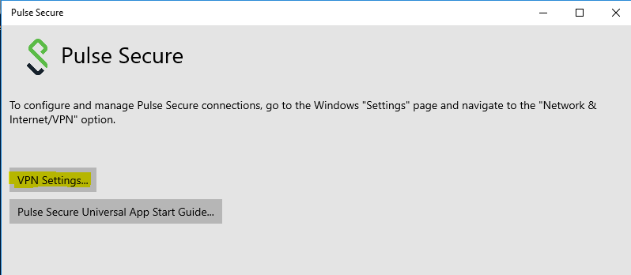

1. Click on **Add a VPN connection**

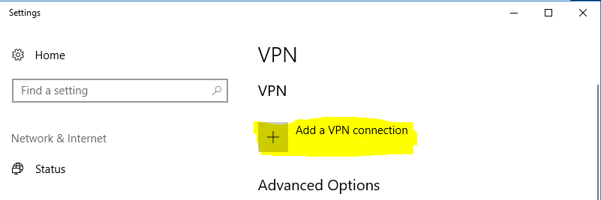

1. In the **Settings** Window, ensure that the **VPN provider** is **Pulse Secure**
2. For the Connection name type FXCM
3. For Server name or address use **fxgw-new.fxcorporate.com/duo**

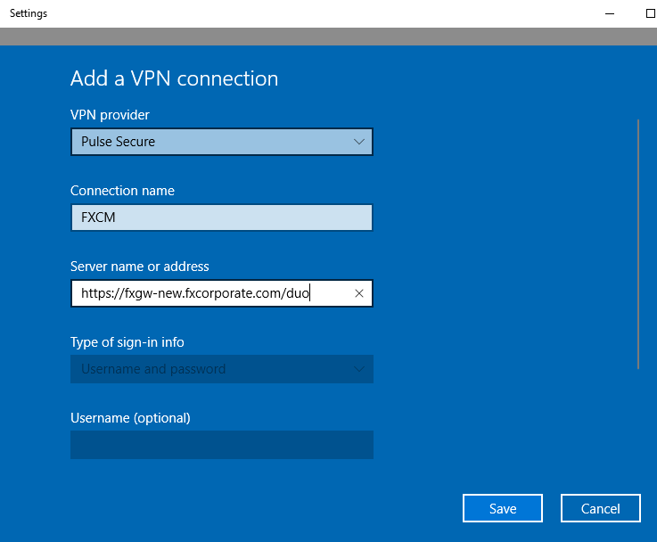

1. Click Save
2. Click the network icon

(If connected wirelessly)

[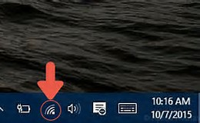](https://www.bing.com/images/search?view=detailV2&ccid=EuR/pDDR&id=6827998D81A212DB884C99D5900976144AFF68D6&thid=OIP.EuR_pDDR5rRyU_yo6cCisgEsCh&q=windows+10+wireless+icon&simid=608039445409432517&selectedIndex=0)

(If connected by a cable)

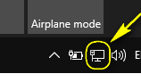

Click on the **FXCM** connection from the list

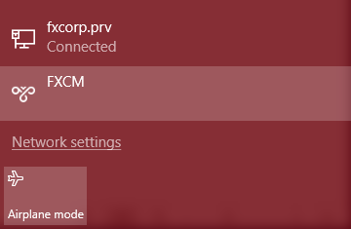

1. Select FXCM from the list and click **Connect**

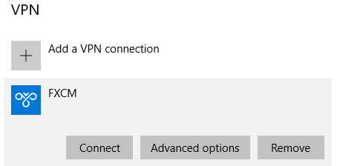

1. At the **Windows Security** window, enter your credentials, as you would if you were logging onto your PC in the office

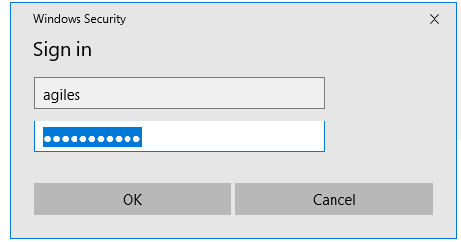

1. You will then be prompted for a secondary password; this is the code that is generated by the Duo Mobile app on your phone.

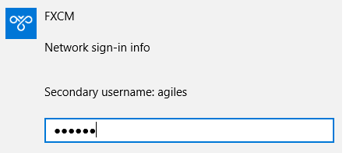

You are now connected.

To disconnect, launch it again in the same way and click **Disconnect**

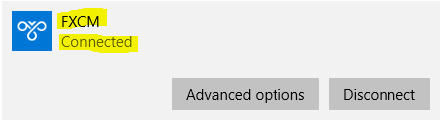

**Connecting to Your Office PC**

1. Next to the Start button, in the search bar, start typing **Remote Desktop Connection**. As you start typing you will see this application appear at the top of list. Click on this to launch it.

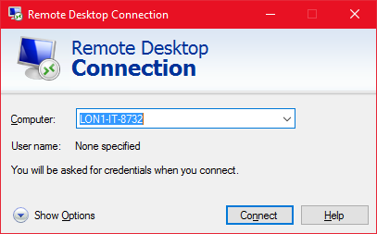

1. When the application opens, simply type in your PC name and click **Connect**
2. When prompted, enter your username and password.